**Implementation of Eye Aspect Ratio and Mouth Aspect Ratio for Driver Drowsiness Detection**

Princy Upadhyay; Lauren Jain; Satya Mishra; Shriya Goyal

***Abstract-*** Street mishaps and related types of mishaps are a typical reason for injury and death among the human populace. As per information from the World Health Organization, about 1.35 million individuals passed away every year because of streetcar crashes[1]. In India, the number of accidents due to driver fatigue is alarmingly high due to continuous driving during the day and night. The effects of drowsiness are similar to those of alcohol, it worsens driving input (steering, acceleration, braking), destroys response times, and blurs thought processes[2]. Interaction between the driver and the vehicle such as monitoring and supporting each other is one of the important solutions to keep oneself safe in vehicles. Numerous lethal mishaps can be prevented if drivers are alerted in time. An immediate method of estimating driver fatigue is to quantify the condition of the driver i.e. drowsiness. The driver drowsiness detection system monitors the driver's eye and mouth using a camera, and by developing an algorithm the system detects signs of driver’s fatigue that are sufficient to keep a person away from sleeping. So, this system is helpful in detecting driver fatigue beforehand and gives warning output as an alarm. While there are numerous approaches to quantify drowsiness yet this methodology is totally non-intrusive which doesn't influence the driver in any way, henceforth it gives the exact condition of the driver. To obtain the degree of drowsiness, the associated features are extracted from facial expressions such as yawning and eye closing. For actualizing this system OpenCV library has been utilized, this library depends on constant facial image examination to alert the driver of drowsiness and inattention to prevent street accidents. Images of the driver's face have been taken by a webcam. An algorithm has been proposed to determine the degree of drowsiness by estimating the duration of an eyelid blink and yawning so that the driver is warned accordingly. The strong point of this proposed system is that the location of the driver is sent to the near and dear ones of the driver so that in the case of an accident with the driver, near and dear ones would get to know on time. In addition, the warning signal is disabled manually instead of automatically. This could ensure the driver's activation as until he sets off the alarm, the alarm is not going to off.

**Keywords –** Driver drowsiness detection; OpenCV; Driver’s fatigue.

1. **INTRODUCTION**

**Driver Drowsiness Detection System**

Drowsiness or tiredness is one of the major factors that compromise street security and causes genuine wounds, deaths, and financial misfortunes[3]. In recent years, the rate of fatal motor vehicle accidents resulting from distracted driving has been increasing. Therefore, there is an urgent need for an alert system to continuously monitor the driver that could alert the driver and reduce the chances of accidents on the roads due to drowsiness problem.

**Signs of Drowsiness**

There are several signs of drowsiness in the driver[4] -

* The driver often yawns.
* The driver can’t keep his eyes open.
* The driver's head tilts and he experiences difficulty keeping his head up.
* The driver's thoughts rove attention from the street.
* The driver can't recall travelling the last couple of miles.

**Methods to Detect Drowsiness**

Numerous works have been done in the field of monitoring and detection of driver drowsiness using various methods.

There are various measures used to compute, disclose and forecast the drowsiness of a driver –

* Subjective measures
* Physiological measures
* Vehicle-based measures
* Behavioral measures
* Hybrid measures[5]

**Principle of Proposed System**

The principle of the proposed system relies on analysis of real-time facial images using the OpenCV library to caution drivers of drowsiness and to prevent street accidents.

The project has gone with Behavioral methods which include -

* Yawning
* Amount of eye closure
* Eye blinking

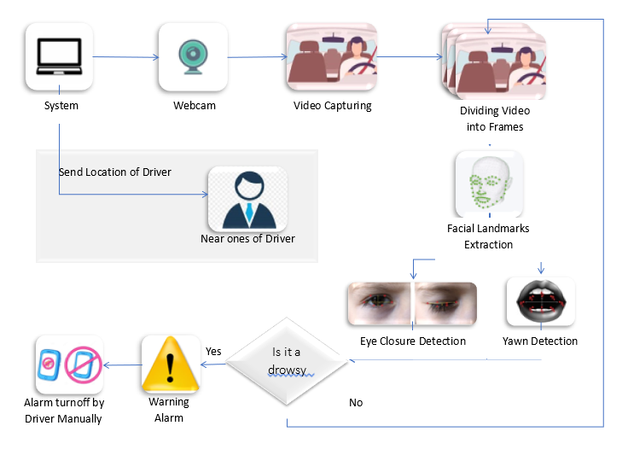

Fig. 1(Block Diagram of Proposed System)

Images of the driver's face have been taken by a webcam[6]. An algorithm has been proposed to determine the degree of drowsiness by estimating the duration of an eyelid blink and yawning so that the driver is warned accordingly. If the eyes are found closed or the mouth is found open for 30 consecutive frames, at that point, the system infers that the driver is sleeping and issues an admonition signal.

Identification of exhaustion has included the sequence of images of a face and the scrutiny of eye movements and blink patterns. Yawning has been included to make the system more precise by determining the movement of the mouth. Once the position of the eyes and mouth has been located, the system can detect fatigue.

**Advantages of Proposed System**

* The location of the driver is sent to the near and dear ones of the driver so that in the case of an accident with the driver, near and dear ones would get to know on time.
* In addition, the warning signal is disabled manually instead of automatically. This could ensure the driver's activation as until he sets off the alarm, the alarm is not going to off.

**2.LITERATURE SURVEY**

To increase accuracy and accelerate the detection of drowsiness, several approaches have been proposed. This section attempts to summarize previous methods and approaches to drowsiness detection.

**2.2.1 EEG-based Drowsiness Detection for Safe Driving Using Chaotic Features and Statistical Tests,** [**Zahra Mardi**](https://www.ncbi.nlm.nih.gov/pubmed/?term=Mardi%20Z%5BAuthor%5D&cauthor=true&cauthor_uid=22606668)**, [Seyedeh Naghmeh Miri Ashtiani](https://www.ncbi.nlm.nih.gov/pubmed/?term=Ashtiani%20SN%5BAuthor%5D&cauthor=true&cauthor_uid=22606668),**[**Mohammad Mikaili**](https://www.ncbi.nlm.nih.gov/pubmed/?term=Mikaili%20M%5BAuthor%5D&cauthor=true&cauthor_uid=22606668)**[7]**

The first class of techniques employs data derived from physiological sensors, such as Electrooculography (EOG), Electrocardiogram (ECG) and Electroencephalogram (EEG) data. EEG signals provide information about the brain’s activity. The three primary signals to measure driver’s drowsiness are theta, delta, and alpha signals. Theta and delta signals spike when a driver is drowsy, while alpha signals rise slightly. According to Mardi et al., this technique is the most accurate method with an accuracy rate of more than 90%. Nevertheless, the main disadvantage of this method is its intrusion. For this, several sensors must be attached to the driver's body, which can be inconvenient. On the other hand, non-intrusive methods are far less accurate for bio-signals.

**2.2.2 Steering Wheel Behavior Based Estimation of Fatigue, JarekKrajewski, David Sommer, UdoTrutschel, Dave Edwards, Martin Golz[8]**

The approach already used is based on driving patterns, and is highly dependent on vehicle characteristics, road conditions, and driving skills. To calculate driving pattern, deviation from a lateral or lane position or steering wheel movement should be calculated. While driving, it is necessary to make micro adjustments to the steering wheel to keep the car in one lane. Krajewski et al. detected drowsiness with 86% accuracy on the basis of correlations between micro adjustments and drowsiness. In addition, it is possible to use lane position deviations to identify driving patterns. In this case, the position of the car corresponding to a given lane is monitored, and deviations are analyzed. Nevertheless, techniques based on driving patterns are highly dependent on vehicle characteristics, road conditions, and driving skills.

**2.2.3 Driver Drowsiness Detection Model Using Convolutional Neural Networks Techniques for Android Application, RatebJabbar∗†, Mohammed Shinoy∗ , Mohamed Kharbeche∗ , Khalifa Al-Khalifa§ , MoezKrichen‡ , KamelBarkaoui†[9]**

Another technique for detecting a driver's drowsiness is through neural networks. RatebJabbar focuses on the detection of such micro sleep and drowsiness using neural network based methodologies. The author proposed a system in which accuracy was enhanced by using facial landmarks that are detected by the camera and passed to CNN to classify drowsiness. The main achievement of this system is its ability to provide lightweight alternatives to heavy classification models with more than 88% for the category without glasses, more than 85% for the category night without glasses. On average, more than 83% of accuracy was achieved in all categories. Nevertheless, the main limitation of this system is its complexity and intensive computation.

**2.2.4 Real Time Eye Detection and Tracking Method for Driver Assistance System, SayaniGhosh, T. Nandy, Nilotpal Manna[10]**

The last category consists of behavioral or computer vision measures that are reliable compared to vehicle-based because they focus on the individual rather than the vehicle. In addition, behavioral measures are non-invasive and more practical than physiological measures. Here, information is obtained using cameras to detect slight changes in the facial expressions of the driver. As behavioral measures are non-invasive in nature, they are becoming a popular method of detecting drowsiness. In this paper, author describes real time eye detection and tracking method that works under variable and realistic lighting conditions. It is based on a hardware system for the real-time acquisition of a driver’s images using IR illuminator and the software implementation for monitoring eye that can avoid the accidents.

**3.METHODOLOGY**

The principle challenge for identifying drowsiness is to determine fatigue by facial expression and to measure it. To do this, the system detects drowsiness in real-time by observing the driver's eyes and mouth. The driver face monitoring system checks the actual condition of the driver based on the processing of the driver's face image. Driver's exhaustion status is identified from eyelids closure, eye blinking, the distance between eyelids, and yawning in this proposed system. Furthermore, if the driver gets tired, the system produces an alarm until the driver becomes alert and recaptures awareness. The stages of the proposed system are described in Fig.2 through a flowchart.

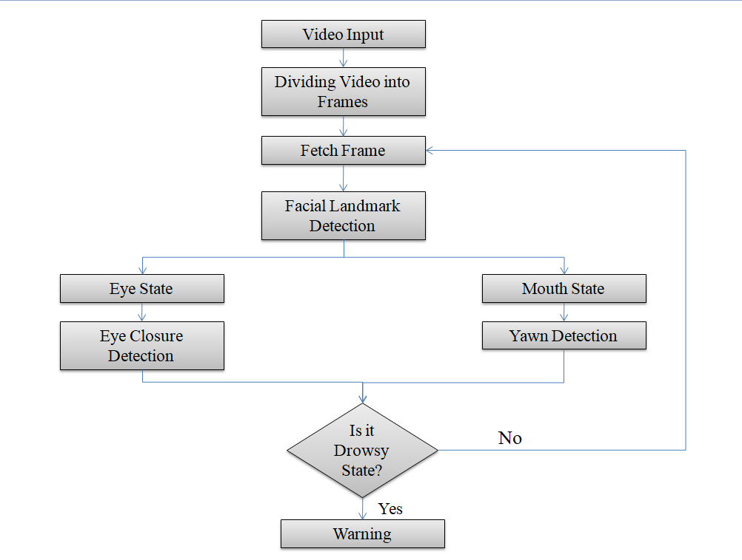

Fig. 2 (Flowchart of Proposed System)

As a first step, the real time video is taken as an input and then the video is divided into several frames and then the frame is used for further processing. In second step, the system locates facial landmarks from the frame. And then features are extracted from facial components and landmarks. The proposed system is able to detect the facial landmarks at different angles and also in dim light as shown in Fig. 3. After the localization of the driver's facial features, the next challenge is to find out the state of eyes and mouth. 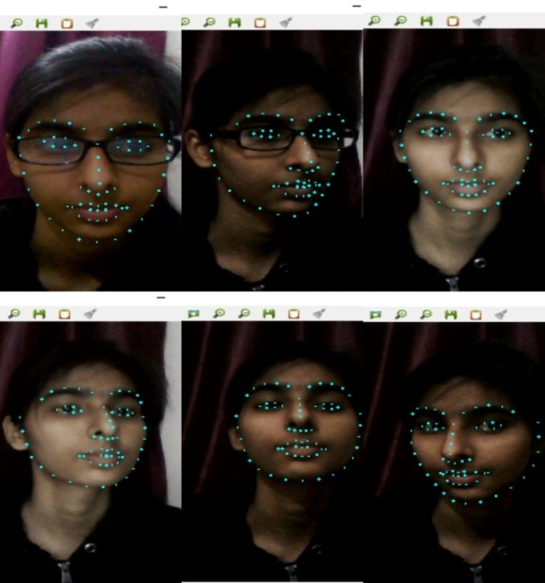

Fig. 3(Facial Landmark Detection)

The blinking ratio is then determined. In case of blink detection, 30 consecutive frames are observed and if the eyes are found closed in those frames then the system count it as a blink and after 3 blinks it gives a warning alarm and if the eyesof the driver are found closed for more than 90 frames then also it generates a warning alarm. The implementation of blink detection is shown in Fig.4. Detection of eye state is not a sufficient factor to determine fatigue and drowsiness, yawning detection is also an essential feature for this. In the yawning position, the mouth becomes wider and the geometric features of the mouth change. When the mouth begins to open, the value of the threshold pixel increases compared to the normal state of the mouth, which is nothing but yawning. In case of yawning, 30 consecutive frames are observed and if the mouth is found open in those frames then the system count it as a yawn and after 2 yawn it gives a warning alarm. The implementation of yawn detection is shown in Fig.5. If one or both of the two conditions occur (eyes closed and yawning), the system defines it as a state of drowsiness and a warning alarm is turned on and it remains on until the driver would have come in a normal state. If the system does not find the driver in drowsy state then it continues to receive frames and perform further processing. Also the location of the driver is sent to his / her near and dear one so that in case of any accident with the driver, the person near and dear to him would get to know on time.

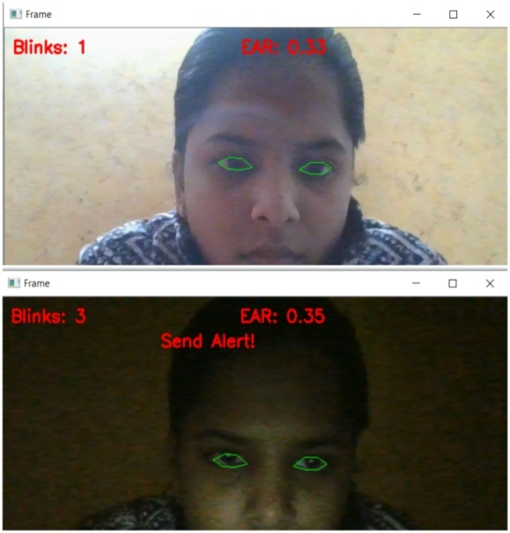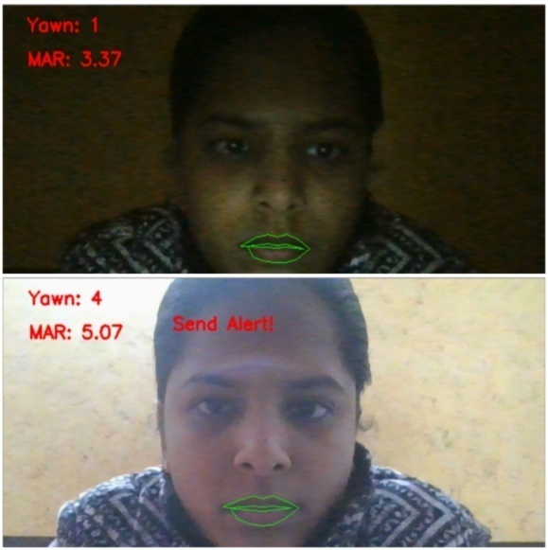

Fig. 5(Yawn Detection)

Fig. 4(Eye Blink Detection)

**Algorithm:**

**Analysis of Eye Aspect Ratio:**

Each eye is sketched by 6 *(x, y)*-coordinates in landmarks retuned Dlib predictor function, starting at the left-corner of the eye and then working right-handed around the remainder of the region. There is a relation between the width and the height of these coordinates are called Eye aspect Ratio.

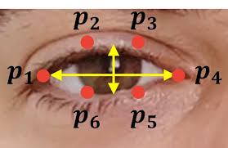

**Analysis of Mouth Aspect Ratio:**

Mouth is sketched by 20(x, y)- coordinates in landmarks returned Dlib predictor function, starting at the left-corner of the mouth and then working right-handed around the remainder of the region. There is a relation between the width and the height of these coordinates are called Mouth aspect Ratio.

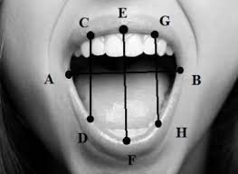

**4.COMPARISON OF VARIOUS METHODOLOGIES**

To increase accuracy and speed up the detection of drowsiness, a few methodologies have been proposed. This part endeavours to investigate past techniques for identifying drowsiness and compares past methodologies with the proposed approach.

**Physiological Method**

This class of methods utilizes information got from the physiological sensors, for example, Electrooculography (EOG), Electrocardiogram (ECG), and Electroencephalogram (EEG) information[11]. EEG signals give data about the brain’s activity. The three essential signs to quantify driver's drowsiness are theta, delta, and alpha signs. Theta and delta signals spike when a driver is sluggish, while alpha signs rise marginally. This strategy is the most precise technique with an accuracy rate of over 90%[11]. Nevertheless, the main drawback of this strategy is its intrusion. For this, several sensors must be placed on the driver's body, which can be inconvenient. On the other hand, non-intrusive methods are far less accurate than bio-signals.

**Subjective Method**

Subjective methods are those which evaluate the degree of drowsiness by the driver's own assessment[12]. The technique utilized here is a questionnaire, normally utilized drowsiness scale is the Karolinska Sleepiness Scale (KSS), a nine-point scale that has verbal anchors for each step[13]. Yet, the principle impediment of this technique is that it is unrealistic.

**Vehicle-based Method**

These estimations are determined in a simulated environment by putting sensors on different vehicle segments, for example, the steering wheel and the acceleration pedal[14]. The signs sent by the sensor are then analyzed to decide the degree of drowsiness. Nevertheless, methods dependent on driving examples are profoundly reliant on vehicle attributes, street conditions, and driving skills. Hence, this methodology is inconsistent.

**Behavioral Method**

In this methodology, the behaviour of the driver including yawning, eye closing, eye blinking are observed through a camera and the driver gets alert signal if any of these drowsiness symptoms are detected[15]. And this approach is reliable compared to vehicle-based approach because it focuses on the individual rather than the vehicle. In addition, behavioral measures are non-invasive and more practical than physiological measures.

The pros and cons of different types of measures are expressed in Table 1[16].

**Table.1(Comparison of Different Measures)**

|  |  |  |  |
| --- | --- | --- | --- |
| **Measures** | **Parameters** | **Advantages** | **Disadvantages** |
| **Physiological measures** | Information derived from the physiological sensors | Reliable, Accurate | Intrusive |
| **Subjective measures** | Questionnaire | Subjective | Unrealistic |
| **Vehicle-based measures** | Steering wheel movement, Standard lane deviation | Non intrusive | Unreliable |
| **Behavioral measures** | Eye closure, yawn | Non-intrusive; Ease of use | Lighting condition Background |

**5. RESULTS**

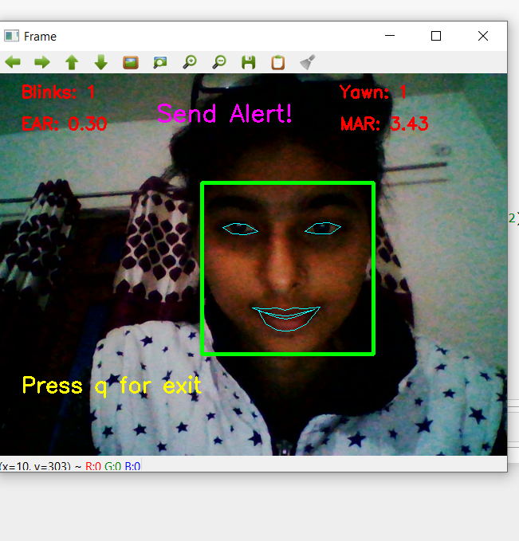

Fig. 6 (Result of proposed system)

**6. CONCLUSION**

In this paper various methods are reviewed for detecting drowsiness of driver. Various measures used to detect drowsiness include subjective, vehicle-based, physical, and behavioral measures[4]; these have been discussed and the pros and cons of each measure are illustrated.The proposed system involves analyzing the facial expression taken by the camera to detect eye blink and yawning. The various motions of the eyes and mouth (such as opening and closing) help detect the level of drowsiness of the driver, which are used to generate warning alarms.

In the proposed system, the driver's drowsiness is detected by analyzing the real-time image taken by the camera using the OpenCV library.

This system involves various steps-

* The face detection using OpenCV library.
* Detection of the eye and mouth using dlib library.
* Detection of the level of drowsiness of driver by calculating Eye Aspect Ratio(EAR) and Mouth Aspect Ratio(MAR).
* Generation of warning alarm according to EAR and MAR values.

**7. REFERENCES**

1. World Health Organization. Global Status Report on Road Safety 2018; [Global status report on road safety 2018 (who.int)](https://www.who.int/publications/i/item/9789241565684)
2. Nora Kamarudin1 , Nur Anida Jumadi1,2,*, Ng Li Mun1 , Ng Chun Keat1 , Audrey Huong Kah Ching1 , Wan Mahani Hafizah Wan Mahmud1 , Marlia Morsin1 , Farhanahani Mahmud. Implementation of Haar Cascade Classifier and Eye Aspect Ratio for Driver Drowsiness Detection Using Raspberry Pi. December, 2019. [UJEEEB9-14990984.pdf (hrpub.org)](http://www.hrpub.org/download/20191230/UJEEEB9-14990984.pdf)
3. Younes Ed-Doughmi 1,* , Najlae Idrissi 1 and Youssef Hbali 2. Real-Time System for Driver Fatigue Detection Based on a Recurrent Neuronal Network. March, 2020. [J. Imaging | Free Full-Text | Real-Time System for Driver Fatigue Detection Based on a Recurrent Neuronal Network (mdpi.com)](https://www.mdpi.com/2313-433X/6/3/8)
4. Taranpreet Kaur and Sanjay Kumar Singh. Enhance the Driver Drowsiness Detection System Using EDAMAS and Region Prop Techniques. [Enhance the Driver Drowsiness Detection System Using EDAMAS and Region Prop Techniques - CORE](https://core.ac.uk/display/26973853)

1. [Muhammad Awais](https://www.ncbi.nlm.nih.gov/pubmed/?term=Awais%20M%5BAuthor%5D&cauthor=true&cauthor_uid=28858220),1,2 [Nasreen Badruddin](https://www.ncbi.nlm.nih.gov/pubmed/?term=Badruddin%20N%5BAuthor%5D&cauthor=true&cauthor_uid=28858220),1,3,* and [Micheal Drieberg](https://www.ncbi.nlm.nih.gov/pubmed/?term=Drieberg%20M%5BAuthor%5D&cauthor=true&cauthor_uid=28858220)3. A Hybrid Approach to Detect Driver Drowsiness Utilizing Physiological Signals to Improve System Performance and Wearability.<https://www.ncbi.nlm.nih.gov/pmc/articles/PMC5620623/>
2. Mudit Arya , Samarth Dixit. Driver Drowsiness Detector.

<http://www.ir.juit.ac.in:8080/jspui/handle/123456789/22793>

1. [Zahra Mardi](https://www.ncbi.nlm.nih.gov/pubmed/?term=Mardi%20Z%5BAuthor%5D&cauthor=true&cauthor_uid=22606668), [Seyedeh Naghmeh Miri Ashtiani](https://www.ncbi.nlm.nih.gov/pubmed/?term=Ashtiani%20SN%5BAuthor%5D&cauthor=true&cauthor_uid=22606668), [Mohammad Mikaili](https://www.ncbi.nlm.nih.gov/pubmed/?term=Mikaili%20M%5BAuthor%5D&cauthor=true&cauthor_uid=22606668). EEG-based Drowsiness Detection for Safe Driving Using Chaotic Features and Statistical Tests, [Zahra Mardi](https://www.ncbi.nlm.nih.gov/pubmed/?term=Mardi%20Z%5BAuthor%5D&cauthor=true&cauthor_uid=22606668). May-Aug, 2011;

<https://www.ncbi.nlm.nih.gov/pmc/articles/PMC3342623/>

1. JarekKrajewski, David Sommer, UdoTrutschel, Dave Edwards, Martin Golz[. Steering Wheel Behavior Based Estimation of Fatigue. June, 2009; <https://ir.uiowa.edu/cgi/viewcontent.cgi?article=1311&context=drivingassessment>
2. RatebJabbar∗†, Mohammed Shinoy∗ , Mohamed Kharbeche∗ , Khalifa Al-Khalifa§ , MoezKrichen‡ , KamelBarkaoui†. Driver Drowsiness Detection Model Using Convolutional Neural Networks Techniques for Android Application. Jan, 2020;<https://arxiv.org/pdf/2002.03728.pdf>
3. SayaniGhosh, T. Nandy, Nilotpal Manna. Real Time Eye Detection and Tracking Method for Driver Assistance System. 2015;

<https://www.semanticscholar.org/paper/Real-Time-Eye-Detection-and-Tracking-Method-for-Ghosh-Nandy/6d4407b102766cef693c873f4ce37bb19b58bb8c>

1. [Zahra Mardi](https://www.ncbi.nlm.nih.gov/pubmed/?term=Mardi%20Z%5BAuthor%5D&cauthor=true&cauthor_uid=22606668), [Seyedeh Naghmeh Miri Ashtiani](https://www.ncbi.nlm.nih.gov/pubmed/?term=Ashtiani%20SN%5BAuthor%5D&cauthor=true&cauthor_uid=22606668), [Mohammad Mikaili](https://www.ncbi.nlm.nih.gov/pubmed/?term=Mikaili%20M%5BAuthor%5D&cauthor=true&cauthor_uid=22606668). EEG-based Drowsiness Detection for Safe Driving Using Chaotic Features and Statistical Tests, [Zahra Mardi](https://www.ncbi.nlm.nih.gov/pubmed/?term=Mardi%20Z%5BAuthor%5D&cauthor=true&cauthor_uid=22606668). May-Aug, 2011; <https://www.ncbi.nlm.nih.gov/pmc/articles/PMC3342623/>

1. [Alina Mashko](https://www.researchgate.net/profile/Alina_Mashko). Subjective Methods For Assessment Of Driver Drowsiness. December, 2017.

https://www.researchgate.net/publication/322205318_SUBJECTIVE_METHODS_FOR_ASSESSMENT_OF_DRIVER_DROWSINESS

1. M Murugappan. Drowsiness detection during different times of day using multiple features. [(PDF) Drowsiness detection during different times of day using multiple features | M Murugappan - Academia.edu](https://www.academia.edu/7464424/Drowsiness_detection_during_different_times_of_day_using_multiple_features)
2. JarekKrajewski, David Sommer, UdoTrutschel, Dave Edwards, Martin Golz. Steering Wheel Behavior Based Estimation of Fatigue. June, 2009; <https://ir.uiowa.edu/cgi/viewcontent.cgi?article=1311&context=drivingassessment>
3. SayaniGhosh, T. Nandy, Nilotpal Manna. Real Time Eye Detection and Tracking Method for Driver Assistance System. 2015;

<https://www.semanticscholar.org/paper/Real-Time-Eye-Detection-and-Tracking-Method-for-Ghosh-Nandy/6d4407b102766cef693c873f4ce37bb19b58bb8c>

1. [Arun Sahayadhas](https://www.ncbi.nlm.nih.gov/pubmed/?term=Sahayadhas%20A%5BAuthor%5D&cauthor=true&cauthor_uid=23223151), * [Kenneth Sundaraj](https://www.ncbi.nlm.nih.gov/pubmed/?term=Sundaraj%20K%5BAuthor%5D&cauthor=true&cauthor_uid=23223151), [Murugappan Murugappan](https://www.ncbi.nlm.nih.gov/pubmed/?term=Murugappan%20M%5BAuthor%5D&cauthor=true&cauthor_uid=23223151). Detecting Driver Drowsiness Based on Sensors. December, 2012;

<https://www.ncbi.nlm.nih.gov/pmc/articles/PMC3571819/>